Git Assignment Objective: The goal of this assignment is to help you get familiar with basic Git commands and workflows, which are commonly used in real-world software development.

1. Create a New Repository. (done -github repo)

Mkdir NUCLEUSTEQ_AKSHAT

Cd GIT_Class

git init

2. Create a New File (done)



3. Create a Branch (done)



4. Make Changes in the New Branch(done)



5. Create Another Branch (Optional)(done IN ASSIGNMENT1.TXT NEW_FEATURES AND NEW_COMMANDS AS BRANCH )

6. Merge Branches(done)

Merge done on new file assignment1_updated with no merge conflict.

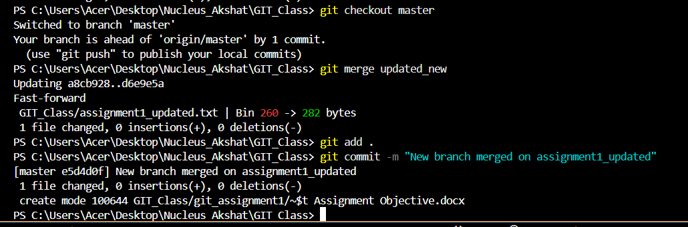

Merge conflict removed for assignment1.txt having branch new_commands and new_features .It was basically due to an old file being deleted during using branch deletion,del file and revert commands in the next steps.Before there were no merge conflict when merging new_features on master as can be seen from history.I have attached screenshot of instances for better reference.

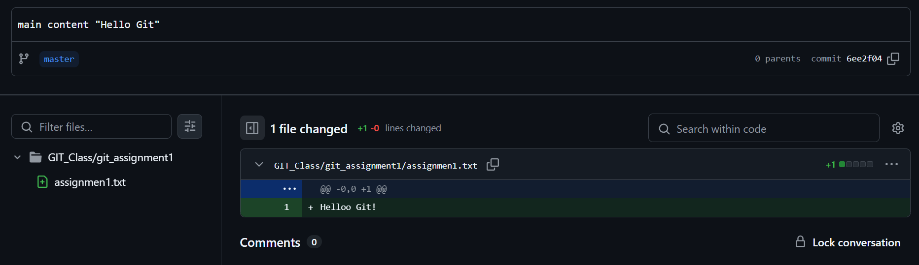

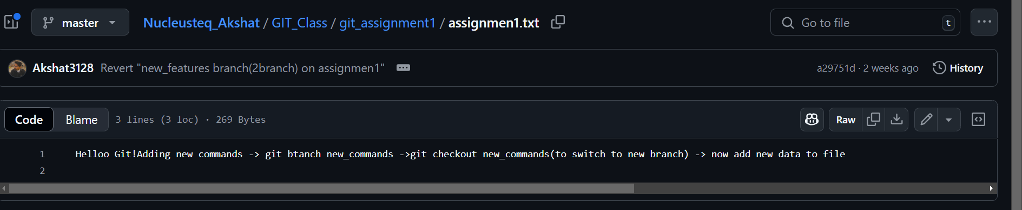

Below is the resolution of merge conflict which happened after deleting one file due to testing and after using revert.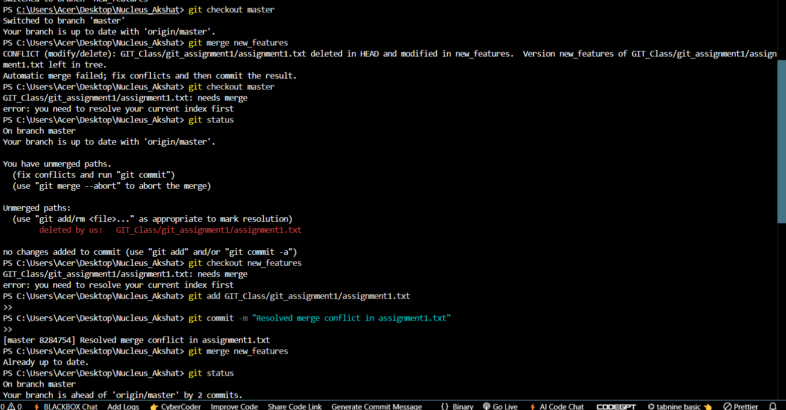

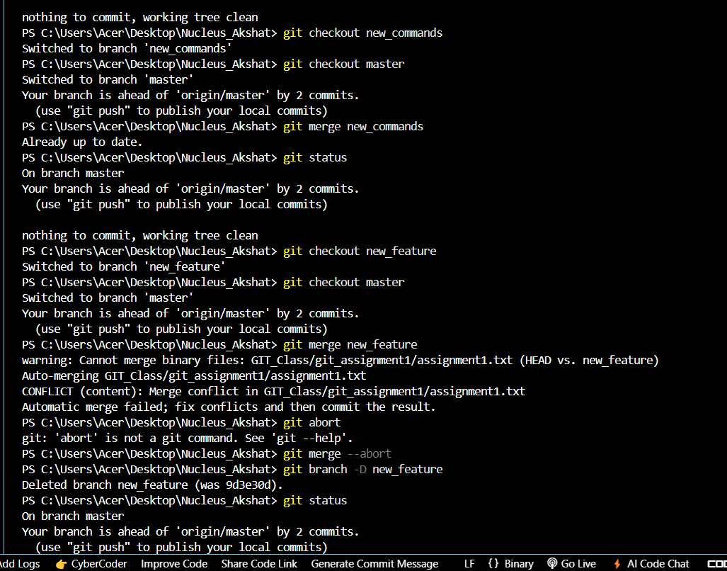

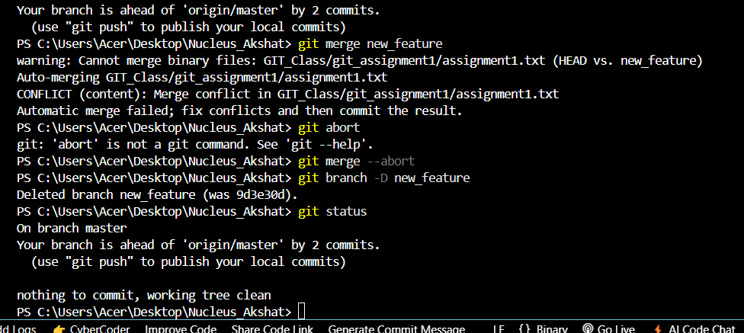

Below is the history for the changes done :

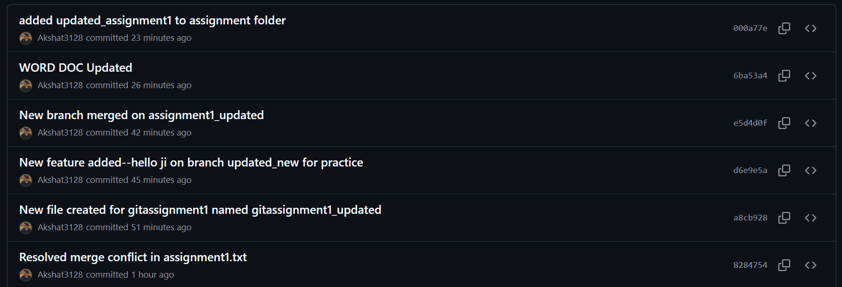

7. Pull Changes from Remote(done as well as push)

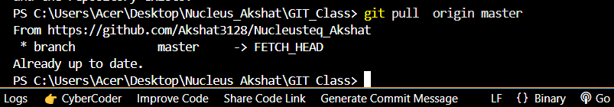

8. View Git Log and History

Used git log –oneline for crisp output in a single line.

Used git –all to see all history from others branches, not just main branch.

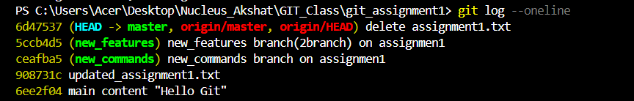

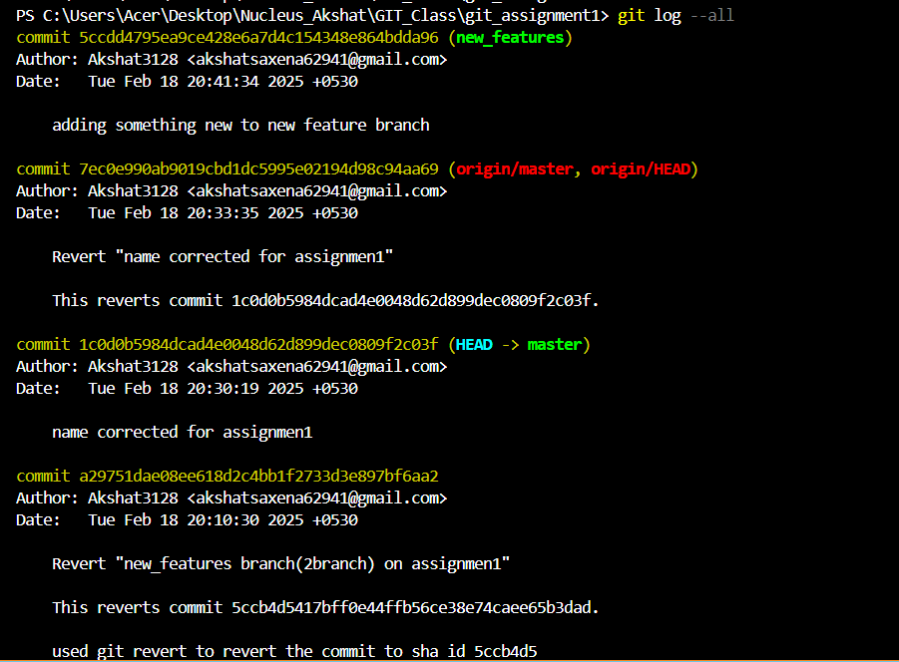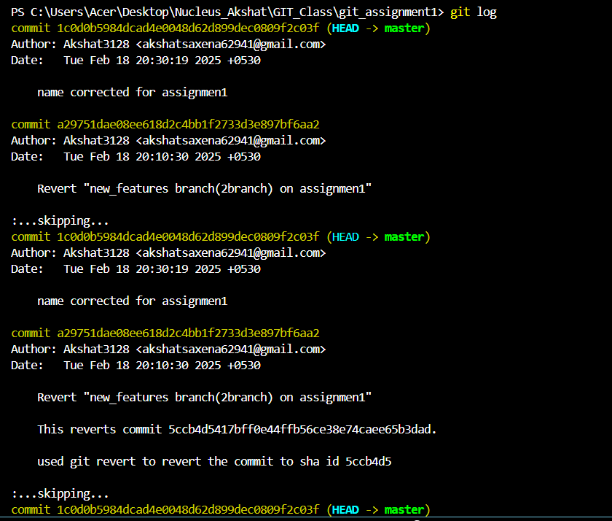­­

9. Git Status and Staging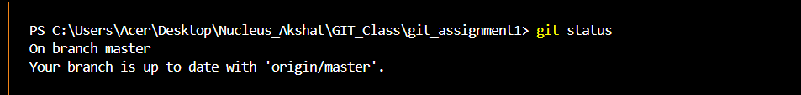

Added assignment1_updated to Staging Area:

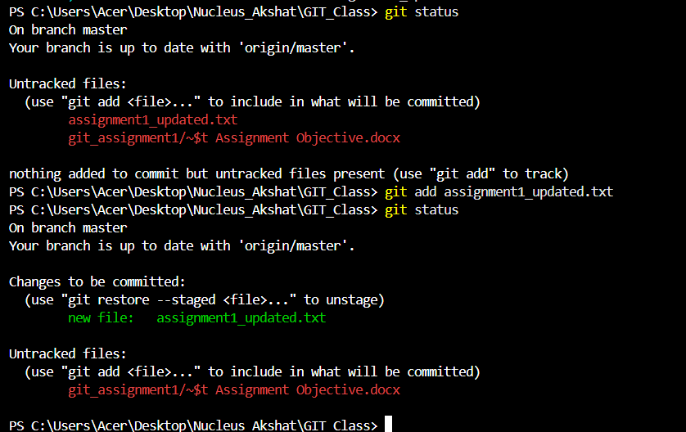

File commited hence removed from staging area:

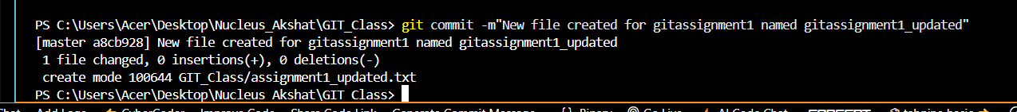

10. Revert and Reset

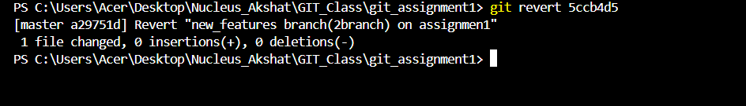

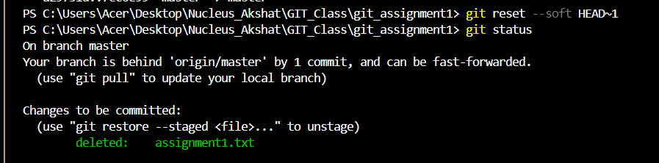

used git reset –soft to undo the last commit while keeping changes –hard can be used to remove changes which can be seen as my local repo is lagging the master repo by 1 commit